The impact of state’s and individual’s ideology on health insurance spending
Aikerim Orken
Nazarbayev University
Abstract
While ideology might have a strong influence on citizen understanding of various socio-demographic phenomena, such as gender roles, wealth distribution, ethics, and inequality, it is unclear how does the ideology correlate with other complicate factors such as healthcare insurance costs. The polarization of the US’ society brings an interesting case to investigate whether states’ or personal ideological views affect the costs associated with the health insurance through the exchanges. In this paper, I focused on the relationship of ideological divide of the states and their citizens’ out-of-pocket spending on a healthcare. The guiding research questions can be formulated as 1) How is state’s and citizen’s ideology connected to household spending on a healthcare insurance? 2) Does the state’s ideology reflect in household out-of-pocket spending in healthcare and tested via the hypotheses: H1) as the ideology shifts from liberal to conservative wing, out-of-pocket spending on a healthcare increases; H2) as state’s citizen’s ideology shifts from liberal to conservative wing, out-of-pocket spending on a healthcare decreases. The data on healthcare insurance marketplace on health and dental plans for the period of 2014 to 2016 from the US Department of Health and Social Services was used on par with the Measures of Citizen and Government Ideology by Richard C. Fording at www. rcfording.com/state-ideology-data/

Introduction
Debates on presidential elections The United States being a country with federal presidential structure of government fosters the variations in ideologies across the states. While many socio-economic aspects of citizens’ life are affected by demographic features such as GDP, age, gender proportion, unemployment, etc. the differences whether one holds to conservative or liberal views also show their impact on individuals’ lives. This paper addresses the issue regarding how well does the ideological preference determine overall performance and quality of the healthcare insurance system. To put in a lаymаn’s term, I investigate the correlation between the conservative ideology and worse health insurance through the exchanges in the United states. Despite the fact that the definition of “better” or “worse” insurance is subjective and can not be stated directly, the following section of literature review will assist me to define what is considered a” good” or a “bad” health insurance. Besides, it will shed a light on current state of academic research on the relationship of political ideology to public health.
Literature review
The political aspects of public health have attracted the attention of academic and political circles only recently (Stewart,2005). Debates that policy making in the area of public health is closely associated with the institutional preferences and ideological inclinations of the state have emerged relatively new stream of academic discussions. Previous studies mostly concentrated in investigation of GDP per capita, age, technological development, and health financing as a key determinants affecting the variance in the national spending on healthcare (Gerdtham and Jöns-son,2000). Focus on political ideology, driven by government or individual believes, as a factor affecting healthcare system became popular in recent decade (Bambra et al.,2005; Prinja,2010).
The American society has never been so polarized as it is today (Banerjee,2019). Nowadays, hot-headed discussion of opposing wings reaches the levels of "high-decibel standing match", as compared by authors. The distinguishable feature of the current situation is that the views are polarized not only regarding the politics but also regarding the main social issues that are considered problematic and the set of actions to address them. Recent studies (Hawkins,2018) show that the core believes of individuals about gender roles or the source of success are better predictors of their political views rather than the income or demographic group they belong to. Therefore, they make a claim that an individual’s views on various policy issues greatly depend on the “affirmation of specific personal values” and not on actual facts or statistical data. Those basic beliefs play a great role in shaping society’s understanding of major issues from immigration to trade, from inequality to taxes, from healthcare to wealth distribution, etc. Consequently, the opinions can be greatly influenced by distorted information and pump up speeches of political figures. In turn, the opinions and ideological believes affect the way people behave or, for example, spend their income.
The divide in opinions is also a common thing in healthcare expenditures. Rightists believe that the best approach in a healthcare is to expose consumers more directly to the medical costs with the minimal government interference in price controls. Common proposals by conservatives advocate for tax system reforms that would discriminate against people with less generous insurance plans (Cohn,2014). Leftist, on the other hand, raise a concern that described policy approaches will punish those who need medical protection the most – ones with medical conditions.

Defining “good” and “bad” healthcare insurance
While it is impossible to fully quantify the cost of a healthcare, most of the researches selected money out-of-pocket as a proxy for the national healthcare spending (Kasper,1983; Saksena,2014). Further on discovering the determinants of national spending on a healthcare it is clear that income and financial aspects play a key role when selecting an insurance plan (Hitiris, 1992; Di Matteo, 2004). The question to be raised is: “Does the less maximum out-of-pocket payments indicate a better health insurance plan?”. The conventional answer would be “Yes”. In other words, the lower the cost of the maximum out-of-pocket payments the more accessible is the medicine. On the other hand, the lower costs are often associated with lower-quality services. Therefore, making a financial cost of a health insurance plan a gauge for the quality of the services. In other words, the amount of maximum out-of-pocket payments by households can serve as a proxy to what can be considered “bеtter” or “worse” healthcare plan. The higher the insurers ask to pay out-of-pocket, the more expensive are medical services and most probably the better the quality of service. Even though that view is conventional it can be contested as well, which is the limitation of this paper.
Hypotheses and variables
H1: Ideology has a significant effect on household’s spending on health insurance.
Since we have an access to the measurement of both state’s government and citizen’s ideology, the hypothesis can be narrowed down and split into two:
  - H1a: The ideology of the state’s government has the effect on the household out-of-pocket spending on health insurance.
  - H1b: The ideology of the state’s citizens has the effect on the household out-of-pocket spending on health insurance.
Given the discussion in the Literature review section, I assume, that as the ideology shifts from liberal to conservative wing, the out-of-pocket payments would increase. As the common rhetoric of the rightists, with less government intervention, i.e. less control on price regulations and provision of subsidies for a health care sector the expected outcome of the research is higher maximum-out-of pocket spendings in the conservative states.
I have selected individual maximum out-of-pocket payments for Tier 1 plans as a dependent variable. Maximum out-of-pocket payment indicate the maximum amount of money that an individual has to pay before insurance company will cover the medical costs. Tier 1 implies of discounted costs of services and medicines within the network of companies and partners of the insurance provider.
One’s spending behavior on health is affected by many factors. Ability to cover the costs, i.e. individual income, defines the constraints on the amount that one is willing to spend on a health insurance. Also, it may be assumed that higher income is associated with increased maximum out-of-pocket payment plans, because individuals can afford to spend more on their health. Another factor that slides into the calculation of out-of-pocket payment limits could be the personal history of using an insurance plan. Costs charged by companies may vary depending on their marketing strategies, which evaluates whether an individual has experience in purchasing an insurance from their company. Such marketing campaigns include discounted monthly premiums for the “loyalty” club members.
Another important demographic aspects such as population’s age and gender proportions might indicate the necessity and amount of an essential health care services.

Methodology and Data
This section describes the methodology implemented to investigate the relationship of ideology on insurance costs. I explored the data provided by the US Department of Health and Social Services on the healthcare insurance marketplace on health and dental plans for the period of 2014 to 2016 across the states and States’ ideology measures reported since 1960 (William,1998). Additionally, I have consolidated the annual data on demographic statistics such as age, income, gender from US Census Bureau. Further on, to investigate the connection between independent and dependent variables I implemented the most common model of multiple linear regression of the following form:
$Y_{it}=α+βX_{it}+θD_{it}+{γI}_{it}+ε_{it}$ (1)
where $Y_{it}$ is the maximum-out-of pocket payments in i state in t period. $X_{t}$ includes the list of control variables, such as percentage of a male population, median age of the state, median household income; $D_{it}$ is the dummy variable that indicates one’s previous experience with a particular provider; $I_{it}$ is the independent variable of my interest : government ideology index.
The second model differs only in the independent variable of my interest - $J_{it}$, citizen ideology index:
$Y_{it}=α+βX_{it}+θD_{it}+{γJ}_{it}+ε_{it}$ (2)
Through running the regression analysis, I want to find whether there is a statistically significant relationship between ideology and individual health spending.
Table 1. Descriptive Statistics
Variable | Obs | Mean | Std.Dev. | Min | Max
Percentage of a male population (%) | 6635 | 49.205 | .408 | 48.2 | 50.5
Median age of the state (years) | 6635 | 37.829 | 2.383 | 30.5 | 44.5
Median household income (2018 inflation adj. $US) | 6635 | 55711.38 | 6118.921 | 41754 | 76126
1=Is the New plan, 0=Existing plan | 6635 | .623 | .485 | 0 | 1
Citizen ideology (index) | 6635 | 47.896 | 10.204 | 21.605 | 70.446
Government ideology (index) | 6635 | 35.924 | 14.593 | 18.113 | 67.982
Maximum out-of-pocket payments of Tier 1 plans ($US) | 6635 | 4781.09 | 2056.633 | 150 | 6850
Table 1 above represents the summary statistics on independent and dependent variables of a consolidated and cleaned dataset.
Results
Preliminary glance at distribution of average maximum out-of-pocket payments (MOOP) across the years in Charts 1 – 3 strikingly illustrates that on average costs associated with health insurance have risen and have shifted from left to right of the horizontal axis. Of course, due to limitations the panel data consolidated from various data sources is unbalanced, therefore, might demonstrate minor distortions. However, the absence of outliers might be a good signal that taking an average of a client-level data in the state, have represented the state’s overall picture on health care.
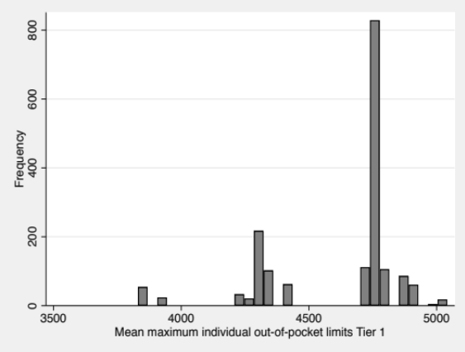
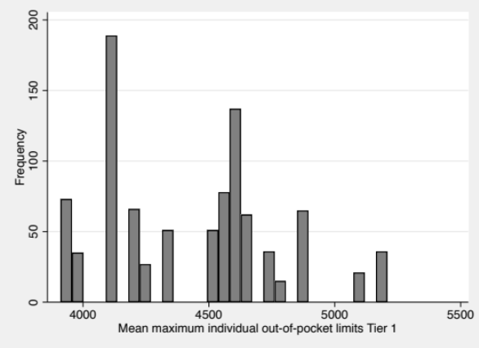 Chart 1. Distribution of mean MOOP Tier1 in 2014 Chart 2.Distribution of mean MOOP Tier1in 2015
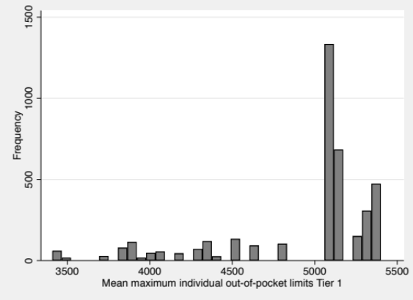

Chart 3. Distribution of mean MOOP Tier1 in 2016
Further, the result of a multiple linear regression models (1) and (2) in Table 3 have both shown that the ideology impact on average MOOPs is statistically significant both institution and citizen-wide. However, the relationship hypothesized in H1a does not hold, since the positive coefficient of institute ideology indicates there is a positive relationship between MOOP and ideology. Thus, as the value of state government ideology index increase (shifts towards liberal) the MOOP increases proportionately. Therefore, the H1a is rejected.
Another, interesting observation is that the H1b tested by model (2) can not be rejected. Thus, it implies that the ideology of the state’s citizens has the effect on the household out-of-pocket spending on health insurance and the relationship is negative. This finding suggests that as the citizen’s views shift from conservative to liberal the average MOOP decreases.
This peculiar features can be observed from Chart 4 and Chart 5. As the results in Chart 4 show, the states with more conservative government demonstrate lower average MOOPs while in Chart 5 it is vice versa, though difference is not severe. Another interesting feature is that the average MOOPs is centered in Chart 4 than it is in Chart 5.

Table 3 Regression model results
 | (1) | (2)
 | Mean maximum individual out-of-pocket limits Tier 1 | Mean maximum individual out-of-pocket limits Tier 1
Percentage of male population (%) | 82.96*** | 93.83***
 | (17.53) | (18.27)
Median age of the state (years) | -32.23*** | -9.142**
 | (3.987) | (3.220)
Median household income (2018 inflation adj. $US) | 0.0127*** | 0.0202***
 | (0.00117) | (0.00112)
1=Is the New plan, 0=Existing plan | 107.2*** | 116.2***
 | (10.90) | (11.05)
State Government Ideology | 4.911***
 | (0.614)
State Citizen Ideology |  | -1.271
 |  | (0.790)
Constant | 964.8 | -628.3
 | (962.6) | (961.2)
N | 6635 | 6635
R² | 0.118 | 0.110
Note: Standard errors in parentheses. * p < 0.05, ** p < 0.01, *** p < 0.001

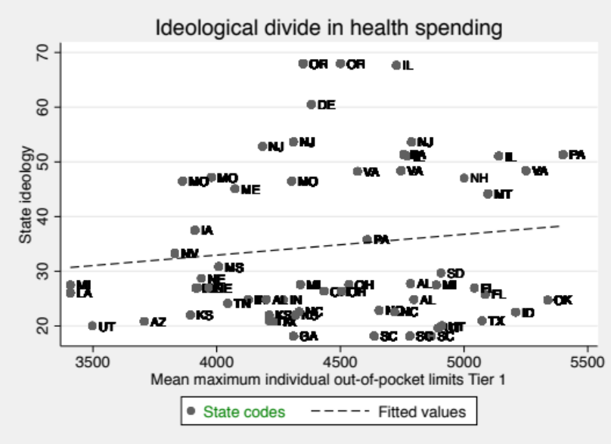

Chart 4. Scatter plot of shifts state ideology and average MOOPs by state.
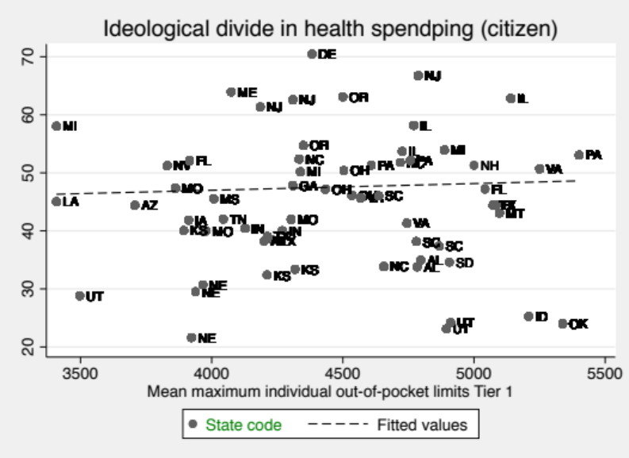
Chart 5. Scatter plot of shifts in citizen ideology and average MOOP by state.

Conclusion
This paper attempted to explore the relationship between ideological views and better health insurance through exchanges. As the results show, ideological views indeed contribute a significant amount in determination of average maximum out-of-pocket spending. However, the assumption held in the beginning the study on higher maximum out-of-pocket payments in rather conservative states does not hold in all cases. As the findings illustrate, the citizen’s ideological views have negative relationship with mean MOOPs and the opposite is true for the state’s government ideology. This findings bring up at least the following questions for a further research :1) What determines the discrepancies between citizen’s and government’s ideological beliefs 2) Is policy making in healthcare driven mostly by ideology or society needs?

References
Banerjee, A. V., & Duflo, E. (2019). Good Economics for Hard Times: Better Answers to Our Biggest Problems. Penguin UK.
Bambra, C., Fox, D., & Scott-Samuel, A. (2005). Towards a politics of health. Health Promotion International. https://doi.org/10.1093/heapro/dah608
Cohn J. (2014). The paradox of reducing health care spending. The Milbank quarterly, 92(4), 656–658. https://doi.org/10.1111/1468-0009.12087
Di Matteo, L., 2004. What drives provincial health expenditure. Canadian Tax Journal/ Revue fiscale canadienne Canadian Tax Journal, 52(4), pp.1102-1120.
Gerdtham, U. G., & Jönsson, B. (2000). International comparisons of health expenditure: theory, data and econometric analysis. In Handbook of health economics (Vol. 1, pp. 11-53). Elsevier.
Hitiris, T. & Posnett, J., 1992. The determinants and effects of health expenditure in developed countries. Journal of Health Economics, 11(2), pp.173-181.
Ifa, A., & Guetat, I. (2019). The Short and Long Run Causality Relationship Between Public Health Spending and Economic Growth: Evidence from Tunisia and Morocco. Journal of Economic Development, 44(3), 19-39.
Kasper, J. A., & Wilson, R. (1983). Use of prescribed medicines: a proxy indicator of access and health status. International Journal of Health Services, 13(3), 433-442.
Prinja, S. (2010). Role of ideas and ideologies in evidence-based health policy. Iranian journal of public health, 39(1), 64.
Saksena, P., Smith, T., & Tediosi, F. (2014). Inputs for universal health coverage: a methodological contribution to finding proxy indicators for financial hardship due to health expenditure. BMC health services research, 14(1), 577.
Hawkins, S., Yudkin, D., Juan-Torres, M., & Dixon, T. (2018). Hidden tribes: A study of America’s polarized landscape. Hidden Tribes. Accessed at https://hiddentribes.us/
William D. Berry, Evan J. Ringquist, Richard C. Fording, Russell L. Hanson. 1998. Measuring Citizen and Government Ideology in the American States, 1960-93. American Journal of Political Science, Vol. 42, No. 1 (Jan.), pp. 327-348.

